Environmental Baseline studies of Kaghan Temperate Coniferous Forest Landscape with reference to amphibians and reptiles

Preliminary Baseline Report, 2017
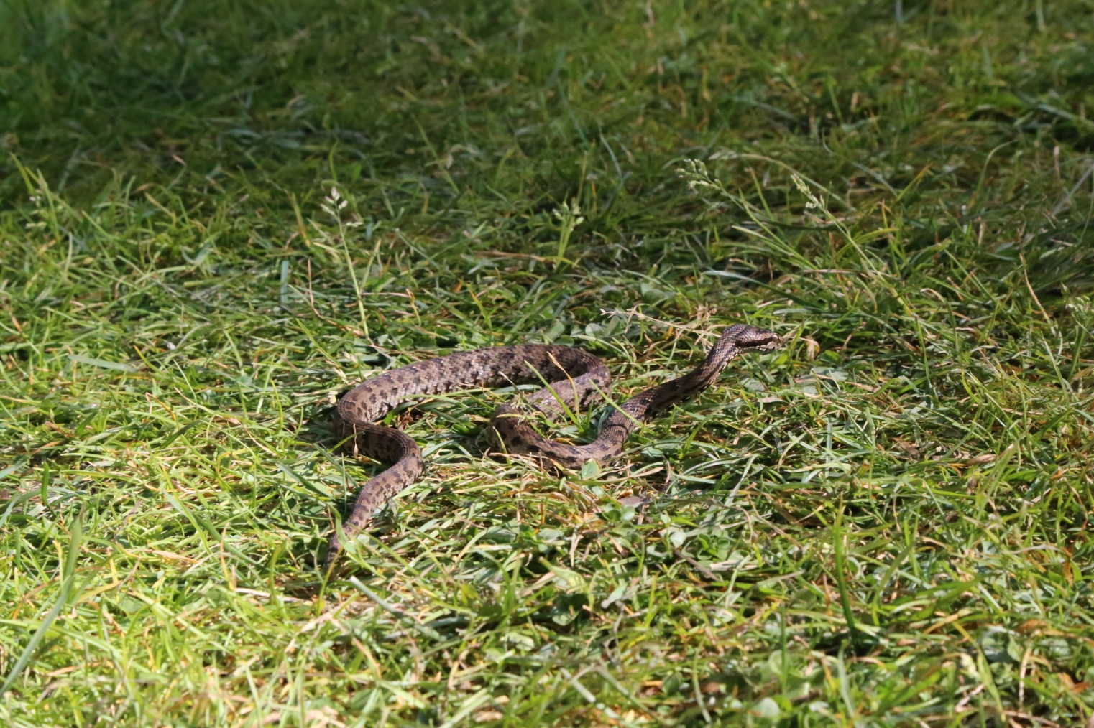

Himalayan Pit-viper: Gloydius himalayanus

By

Rafaqat Masroor

Acknowledgements

I am grateful to the management of Sustainable Forest Management program in general and particularly to Mr. Muhammad Ayaz Khan (National Project Manager) and Najam-ul-Huda (Manager, SFM) who provided and extended their support and resources to finalize these studies. My work will not be produced without the help and restless field support by all of my colleagues especially team Incharge Dr. Khalid Mehmood (PMNH).
I am also much indebted to all members of the project team for providing support of any kind in the field in gathering the required information.

Rafaqat Masroor
Consultant

List of Abbreviations

EIAO Environmental Impact Assessment Ordinance
CITES Convention on International Trade on Endangered Species of Flora and Fauna
ha Hectare
IUCN The World Conservation Union
m Meters
mm Millimeters
PMNH Pakistan Museum of Natural History
SVL Snout to Vent Length
WWF-Pakistan World Wide Fund for Nature – Pakistan
_____________________________________

List of tables and figures

Tables

Table-1 | Amphibian and Reptilian species of Kaghan Temperate Coniferous Forest | 15
Table-2 | Abundance and Diversity of Herpetofauna by sampling transects, Survey Conducted September 2017 | 16

Figures

Figure 1 | Map showing Kaghan Temperate Coniferous Forest | 9
Figure 2 | 3-D map of Manshi Forest | 10
Figure 3 | Bufo pseudoraddei pseudoraddei, Mertens green toad | 17
Figure 4 | Laudakia himalayana, Himalayan rock agama | 18
Figure 5 | Gloydius himalayanus, Himalayan Pit-viper | 19
Figure 6 | Asymblepharus himalayanus, Himalayan Ground skink | 20

_____________________________________
Summary

Sustainable Forest Management (SFM) Project" is a joint venture of the Government of Pakistan, UNDP, and GEF. SFM aims at promoting sustainable forest management in Pakistan's forests for mitigating climate change and securing ecosystem services. This report is an outcome of the field expedition carried out in September 2017 to explore the amphibians and reptilian diversity in the Kaghan Temperate Coniferous Forest Landscape.

For the seven reported amphibians and reptiles from the study area, the information pertaining to the amphibians and reptilian diversity, ecology and other related aspects are based on the review of pertinent literature, author’s previous work, communication with the local people, their experience in the study area and the author’s field observations and collection during the field studies. Herpetofauna with regards to different ecological zones has also been mentioned and its association with the respective zone discussed.

Since the available time for present studies was extremely limited (the herpeto-faunal species assessment always needs extended time, may be in years, for precise determination of numbers), previous documentation in the form of fragmentary reports from the nearby areas has also been used to prepare a consolidated list of the species likely to occur in the Kaghan Temperate Coniferous Forest Landscape.

_____________________________________

1. Introduction

Sustainable Forest Management: Project Brief

Project Title: | Sustainable forest management to secure multiple benefits in Pakistan's high conservation value forestss
Duration: | Five years (January 2017 to December 2021)
Project Areas: | i). Khyber Pakhtunkhwa (Temperate forest)  ii). Sind (Riverine forest)  iii. Punjab (Scrub forest and Riverine forest)
Project objective: | The objective of the proposed project is to promote sustainable forest management in Pakistan's Western Himalayan Temperate coniferous, Sub-tropical broadleaved evergreen thorn (Scrub) and Riverine forests for biodiversity conservation, mitigation of climate change and securing of forest ecosystem services. In particular, it aims at implementation of three inter-related and mutually complementary components that are focussed at addressing the barriers of inadequate planning, regulatory and institutional frameworks to integrated forest resource management, and enhancing the limited experience among key government and civil society stakeholders in developing and implementing SFM practices on the ground.
Project outcomes: | Outcome 1: Embedded sustainable forest management into landscape spatial planning;  Component/Outcome 2: Biodiversity conservation strengthened in and around High Value Conservation Forests; and  Component/Outcome 3: Enhanced carbon sequestration in and around HCVF in target forested landscapes
Description | The objective of the proposed project is to promote sustainable forest management in Pakistan's Western Himalayan Temperate Coniferous, Sub-tropical broadleaved evergreen thorn (Scrub) and Riverine forests for biodiversity conservation, mitigation of climate change and securing of forest ecosystem services. In particular, it aims at implementation of three inter-related and mutually complementary components that are focussed at addressing the barriers of inadequate planning, regulatory and institutional frameworks to integrated forest resource management, and the limited experience among key government and civil society stakeholders in developing and implementing SFM practices on the ground.  Component 1 will support the incorporation of sustainable forest management objectives and safeguards in forest management planning, forestland allocation and compliance of monitoring systems at the local level. Component 2 will identify, demarcate and implement on-the-ground approaches to improving management of high conservation value forests within seven landscapes covering an area of 67,861 ha with the aim of meeting the life requisites of the target species, and habitats such as breeding areas, feeding areas, water sources, dispersal and connectivity corridors, etc.  Component 3 will develop practical approaches to enhancing carbon sequestration through restoring degraded and former forested areas (LULUCF activities) by a combination of restoration and reforestation of 10,005 ha of degraded conifer forests; 3,400 ha of degraded scrub forests, and reforestation of 13,099 ha of Riverine forests with native species.  The project is funded by GEF and UNDP and implemented by jointly by UNDP Pakistan and Minstry of Climate Change in Khyber Pakhtunkhwa, Sind, and Punjab.
Project Outputs | 1.1 Forest resources and ecosystem services inventory and mapping informs forest management planning, implementation and monitoring at the landscape level  1.2 Updated guidelines, planning tools and regulations facilitate harmonization and mainstreaming ecosystem, climate risk mitigation and biodiversity considerations into forest management planning  Output 1.3. Landscape level forest plans integrates considerations of biodiversity, ecosystem services, climate mitigation and community resource use  Output 1.4 Stakeholders’ benefits of current unsustainable and sustainable forest practices and status of forest resources assessed  Output 1.5 System for effective monitoring and enforcement of forest management plans, including clear delineation of roles and responsibilities of key partners and management of participatory processes informs forest management and development  Output 1.6 Forest resource use conflict management and resolution processes established in multiple use zones  Output 1.7 Capacity building for provincial and district level forest agencies, local communities and other stakeholders, including (i) training workshops and courses (ii) vocational training modules (iii) on-the-ground demonstration and training and (iv) patrolling skills and forest fire controlling training enhances capacity for sustainable land and forest management within key agencies and communities.  1.8 Recommendations for facilitating adoption (institutionalising), scaling up and replication of sustainable forest management practices promoted  Output 2.1 Avoided deforestation of High Conservation Value Forests with forest use regime change from unsustainable use to biodiversity conservation and non-exhaustive community forest management instituted  Output 2.2 Community-Managed Conservation Area model of community governance and management system operational  Output 2.3 Biodiversity conservation and capacities in and around high conservation value forests reinforced through training, enhanced enforcement, guidelines and strengthening with community managed conservation forests and involvement of communities in state managed forests  Output 3.1 Restoration of degraded Temperate Conifer forests and Sub-tropical Broadleaved Evergreen Thorny forests with indigenous species, realizing carbon benefits  Output 3.2 Reforestation of degraded Riverine forests with indigenous species, realizing carbon benefits and biodiversity conservation  Output 3.3 Best practice silvicultural approaches to forest restoration and reforestation documented, and capacities enhanced through training and local language guidelines.  Output 3.4 On-the-ground application of Nationally-tailored methodology for measuring carbon stocks (to be developed under a parallel REDD Readiness Preparation Project) applied, demonstrated and validated for the target areas.

Kaghan Temperate Coniferous Forest Landscape is situated in the Himalayan Moist Temperate zone of Pakistan in the district of Mansehra in Khyber Pakhtunkhwa Province (KP). The project document outlines the various features of the project as under:

The documented flora of the area consists of coniferous trees including Cedrus deodara, Pinus wallichiana, Abies pindrow, Taxus wallichiana, Picea smithiana, and broad-leaved trees such as Juglans regia, Aesculus indica, Prunus padus, Fraxinus excelscior, Ailanthus glandulosa, Diospyrus lotus, Morus alba and Ficus indica are found in these landscapes. Taxus wallichiana and Fraxinus excelscior are endangered, the former is included in IUCN Red Data Book, and the latter is endangered nationally due to excessive utilization and poor regeneration because of long gestation period of eighteen months for germination of seed, during which it is liable to be washed or blown away or suffers decay. Parrotia jacquemontiana amongst shrubs, Sassure alappa (listed in Appendix-I of CITES) and Trillium guavaninium amongst herbs are mentioned here due to the threatened status nationally because of over exploitation. There are many NTFPs in the area and the area has great potential for local employment from co-tourism.

Likewise, the wild fauna of the area consists of mammals including common leopard (Panthera pardus), black beer (Ursus thibetanus), langur (Semnopithecus ajax), rhesus monkey (Macaca mulatta), jackal (Canis aureus indicus), fox (Vulpes vulpes), squirrel spp. (Eupetaurus cinereus); and avifauna includes pheasant species of monal (Lophophorus impejanus) and koklass (Pucrasi amacrolopha) etc.
Ecosystem goods and services provided by the landscapes include timber, fire wood, fodder, grazing, fish, NTFPs, water, clean air, carbon sequestration, soil conservation, biodiversity conservation, aesthetic landscapes, countryside recreation and ecotourism. The land uses in the landscapes are forestry, grazing, agriculture, wetlands, and communication infrastructure and human settlements. The communities in these two landscapes are poor and mostly depend on marginal agriculture, non-farm jobs, and goods and services from communal as well as state forests such as timber, firewood, fodder, grazing, NTFPs.

Figure 1: Map showing Kaghan Temperate Coniferous Forest

The planned project activities include protection of stocked and under-stocked forests for enhancement of carbon stock, avoidance of deforestation and forest degradation, biodiversity conservation; restoration of under-stocked areas with less than 25 % cover and reforestation in larger blanks by planting saplings and seedlings raised in local nurseries; involvement of communities, awareness raising; forest fire management including early warning system, sustainable harvesting, processing and marketing of NTFPs, preparation and implementation of ecosystem based landscape management plans; and assessment of carbon stocks and promoting trading of carbon credits.

The state forests include Nagan Reserve Forest (1,637 ha), Manshi Reserve Forest, also a wildlife sanctuary (2,368 ha), Kamal Bann Reserve Forest (2,212 ha), Malakandi Reserve Forest (1,923 ha) and NuriBichla Reserve Forest (1,787 ha); and Guzara forests include GanilaGuzaraForesy (114 ha), BageerGuzara Forest (2,896 ha), HungraiGuzara Forest (415 ha), BelasachaGuzara Forest (364 ha), SuanGuzara Forest (554 ha), ShukraGuzara Forest (67 ha), PhagnaGuzara Forest (871 ha), ChushaalGuzara Forest (258 ha), Jared Guzara Forest (526 ha), Kamal Bann Guzara Forest (84 ha), BhoonjaGuzara Forest (2,208 ha) and NuriGuzara Forest (57 ha).
The area of above five state forests is 9,927 ha and the area of twelve Guzara (communal) forests is 8,414 ha, the total forested area in the landscape is 18,341 ha. The total area of the landscape is 22,000 ha.
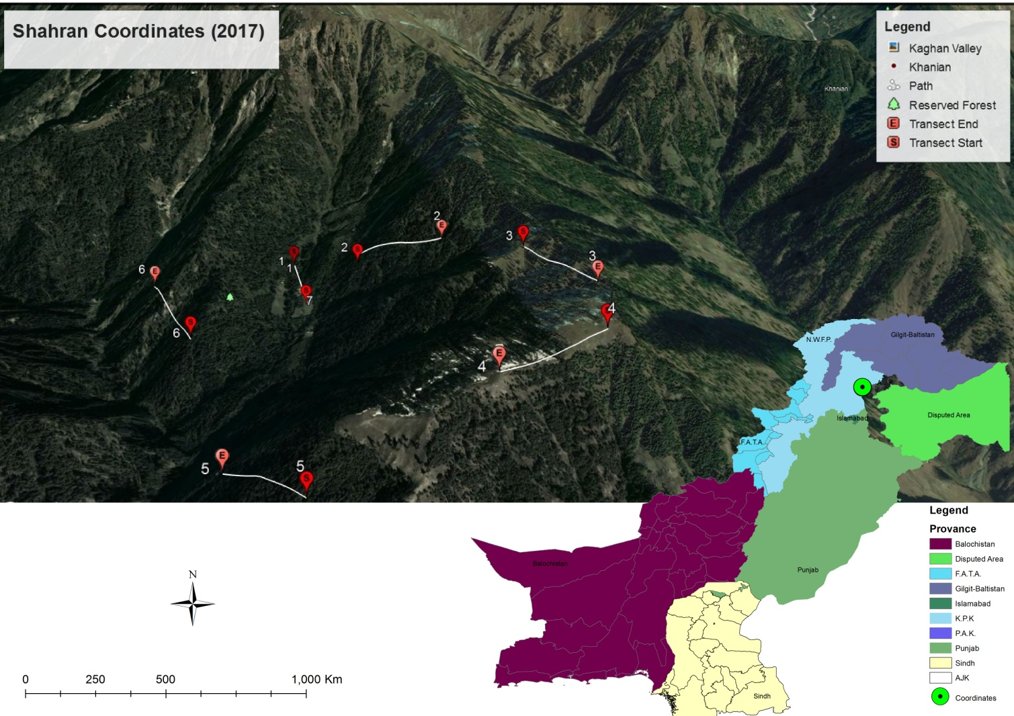
There are about 80 villages and hamlets situated in and around these forests which consist of approximately 54,000 households and 9,000 forest dependent local persons.

Figure 2: 3-D map of Manshi Forest

  - Objectives of the present studies
This study was envisaged to provide for the first time, a comprehensive ecological and systematic account of the amphibians and reptiles of the Kaghan Temperate Coniferous Forest Lanscape. The prime objectives of the study were to:
- Collect and review secondary data on the reptile and amphibian species of the study lakes, using the available literature and local inhabitants.
- Collect data from the field on amphibian and reptilian species occurrence, abundance and diversity in the study areas.
- Prepare a taxonomical checklist of all the species with their English and local names and their status in the study sites.
- Identify threatened amphibian and reptile species in the study sites, if any and recommend measures to improve the situation.
- Assessment of impacts from environmental changes and human population pressure on potential reptilian and amphibian species and their habitats and to suggest associated mitigation steps.
- Provide photographs, where possible, of the amphibians and reptiles species.
- Compile a report on the consultancy addressing all the above-mentioned issues.

1.3. Scope of the study
Amphibians and reptiles are very important animals among the vertebrates. Amphibians show the transition of aquatic and terrestrial life. Reptiles were the first fully terrestrial forms of life. Apart from their impressive evolutionary history, they beautifully demonstrate different concepts of physiological and behavioural adaptation to different climates, from tropical forests to hot desert and marine to fresh -water. They have not the ability to travel long distances like birds and mammals. In response to any local environmental changes they respond quickly and therefore may act as excellent biological indicators.
Amphibians and reptiles are important components of any living system and play a key role in interlocking web of nature. At one end they prey upon insects and other invertebrates and therefore regulate the population of these animals and on the other hand they are also a major source of food for other carnivore species (birds and mammals). Their position in the ecological niche is so vulnerable that the survival and collapse of the whole energy cycle depends upon the presence and absence of the amphibians and reptiles. The existence and sustainable use of this biological resource is therefore imperative around the study sites.
Despite the fact that amphibian and reptiles are important biological resource, unfortunately very little attention has been given to these creatures in Pakistan. The major hurdle presumably is the lack of sufficient expertise and awareness in this particular field. Moreover, our society in general and rural folk in particular is mostly repulsive and afraid of reptiles. The results of the present study will enable us to know about the natural wealth of all the North-west alpine lakes in terms of amphibians and reptiles. Furthermore, the status of all the species of amphibians and reptiles will be evaluated so that in any adverse circumstances the conservation strategies shall be suggested.

1.4. Literature Review on Amphibians and Reptiles of Kaghan Temperate Coniferous Forest
Despite the efforts of some early herpetologists (Murray, 1884, 1886; Boulenger, 1890, 1920; Smith, 1933, 1935, 1943; Minton, 1966; Mertens, 1969; Dubois & Khan, 1979; Khan, 1979, 1980), the northern areas of Pakistan have only been marginally explored herpetologically. This is because of the fact that the area is extremely difficult with very limited infrastructure and other facilities. The conditions were even worse in the past, which did not encourage the people to go there. Secondly, amphibian and reptiles are cold-blooded animals and therefore are more sensitive to the environmental condition as compared to birds and mammals. However, in the recent past, Baig (1988 a, b, c; 1989, 1990, 1992, 1996, 1997, 1998, 2001 a, b, 2002); Khan and Baig, (1988, 1992)); Khan and Tasnim (1989, 1990); Baig & Böhme (1991, 1996); Khan (1989, 1993, 1997, 1998); Baig and Gvozdik (1998); Auffenberg & Rehman (1993); Woods et al. (1997) and Shah and Baig (2001) attempted to explore these areas and published their findings, which were surprisingly, either new to the science or extended the range of several species which were only reported from the neighboring countries of Pakistan. All these preceding studies were, however, limited to the chance collection in the selected areas and specific habitats were not targeted to document the herpetofauna very well.
Although no baseline is available on the amphibians and reptiles of the present study area yet as per earlier fragmented works from the nearby regions and the possible distribution range of several amphibians and reptiles, not only the results of present studies but also those from earlier reports have also been included in this report.
Due to lack of experts in the field of herpetology in general and particularly with no previous ecological long-term studies on the herpetofauna of the study area, this report will form the basis to comprehensively document the amphibians and reptiles from the study area.

2. Materials and methods

2.1. Methods of fieldwork
The activities of amphibians and reptiles are highly seasonal and are influenced by the variation of weather even on a daily basis due to their ectothermic and cryptic nature. It is more fruitful to survey them during their active period which is quite obvious in the summer and monsoon season. Amphibians are usually most active just after dusk during their breeding seasons while many diurnal reptiles such as skinks or other lizards are active in mid-morning. However, many other nocturnal reptiles such as certain snakes and geckos would only be active at night.
Most amphibians and reptiles go into hibernation during winter. They would be under-estimated if surveys were carried out during this time. As such, it would be essential to survey herpetofauna at appropriate timings in order to collect a representative baseline for assessment. Indeed, many reptiles such as snakes and lizards are timid, secretive, fast-moving and cryptically colored which render survey on reptiles difficult and therefore reptiles tend to be under-represented in ecological surveys in general. More intensive surveys with appropriate survey methodologies would rectify such limitation.
There are standard methods for the studies of Amphibians and Reptiles (Foster and Gent, 1996; Heyer et al., 1994; Hayek and Martin, 1997). All these techniques have been summarized in the EIAO Guidance Note, 2004. In the present study, however, only active searching in selected line transects was used as a standard method for the maximum observation.

Line transects: For the observation and or collection of amphibians and reptiles, active searching in six line-transects, each of 500 m long and 20 m wide were carried out at the selected habitats (Annexure-I; page 25). Besides the general observations on the presence of the amphibians and reptiles, presence of signs like impression of body, tail or footprints, fecal pellets, tracks, dens and egg laying excavations were also recorded. The observed/collected specimens were identified with the help of most taxonomic recent keys available in the literature. Other parameters like density and diversity of sampling transect in terms of amphibians and reptiles were calculated for each sampling point.
An effective way to survey amphibians and reptiles is by active searching, particularly during the daytime. This method is equally applicable for both nocturnal and diurnal species. The study area was actively searched for potential breeding areas of amphibians (e.g. marsh, small water pools, water channels) and suitable microhabitats for both amphibians and reptiles (e.g. stones, pond bunds, crevices, leaf litter/debris, rotten log). These places were deliberately uncovered to search for the eggs and tadpoles of amphibians in aquatic habitats or to reveal the presence of the amphibians and reptiles hiding under these covers. Active searching was carried out in the whole sites with focus on suitable microhabitats.
Searching for the nocturnal species of amphibians and reptiles was carried out in exposed areas of their potential habitats on the ground, along the path or the pond/stream bank. Night survey in rocky terrain around the lakes was difficult as there was always likelihood of venomous snakes, as the author did face; so, long shoes, hand lamps and powerful torches were used for this purpose.

- Collection
Hand picking (through bare hands or with the help of long forceps or snake clutch), which has been adopted for the present studies, has always been the most efficient way of collecting different species of amphibians and reptiles. However, for larger species like monitor lizard and rock-agama, noose traps or other appropriate techniques were used. For handling snakes, especially poisonous ones, snake clutches/ sticks were used. In addition to Hand picking, “Scoop nets” for shallow water and “cast nets” in large water bodies were used for aquatic reptiles and amphibians. For frogs and toads, auditory detection of mating calls at the breeding sites is considered as an efficient method to find out the species, particularly the more vocal species and therefore a large number of toads were spotted with this method.

- Data Records
The species collected or observed during the survey were photographed with a digital camera and necessary field data were recorded. The coordinates and elevations were recorded with the help of GPS. The voucher specimens collected were subsequently transported to the PMNH laboratory for future reference.

2.2. Methods of laboratory work

Preservation

The amphibians and reptile species were killed instantly by injecting absolute ethanol in their head. Samples of tissue of all the specimens collected from the study areas were preserved in 95% ethanol for further detailed DNA studies in future. The amphibian or reptile specimens were arranged in a tray or ice-cream container in a position, which showed those features important for identification, e.g. mouth wedged open, one hind leg extended and fingers and toes spread.
Preservative such as 10 % formalin solution or 50-70 % alcohol or methylated spirits solution in water was added to just cover the specimens, and the container was then covered and left until the specimens were set. In case of larger specimens, the author made a slit in the belly and injected preservative to preserve the internal organs. This step was omitted in case of frogs as they have thin and permeable skins, but in case of reptiles, the preservative was injected into their bodies as their skin is impermeable and does not allow any solution to get into. For this purpose regular syringes were used.
After that, the specimen was stored in the same preservative in a watertight jar. A waterproof label was added to the jar, giving details of place, date and collector’s name. A label was tied to the specimen written with permanent Indian ink or simple carbon pencil. The same details were stored with tadpole specimens, which don’t need to be set, just dropped into preservative.

Identification of species

The specimens were identified with the help of most recent keys available in literature (Khan, 2003, 2006; Masroor, 2012).

3. Baseline Data with reference to amphibians and reptiles

Six localities of the study area were surveyed from 23rd to 25th September 2017 for the presence of amphibians and reptiles. Both diurnal and nocturnal surveys were arranged and the outlined method was employed for the observation and collection of amphibians and reptiles.
Out of 07amphibian and reptilian species, possibly occurring in the area, four species of amphibians and reptiles were observed/collected. The remaining species have been reported through secondary data and obtained through discussions with the local inhabitants and consulting the previous literature citations. Table-1 presents a comprehensive list of species observed/ collected during present studies and those from literature, which are earlier, reported from the nearby areas.

Table-1: Amphibian and Reptilian species of Kaghan Temperate Coniferous Forest

S. No. | Species Name | Taxonomic Position | English | Activity Pattern | IUCN Status | Feeding Habits
01 | Bufotes pseudoraddei pseudoraddei *  (Mertens, 1971) | Class: Amphibia  Order: Anura  Family: Bufonidae | Swat green toad | Non-specific  (mostly nocturnal) | LC | Insectivore
 | Laudakia tuberculata *  (Gray, 1827) | Class: Reptilia  Order: Sauria  Family: Agamidae | Kashmir rock agama | Diurnal | NE | Insectivore
 | Paralaudakia himalayana **  (Steindachner, 1869) |  | Himalayan agama | Diurnal | NE | Insectivore
 | Asymblepharus himalayanus *  (Günther, 1864) | Class: Reptilia  Order: Sauria  Family: Scincidae | Himalaya ground skink | Diurnal | NE | Insectivore
 | Amphiesma stolatum **  (Linnaeus, 1758) | Class: Reptilia  Order: Serpentes  Family: Colubridae | Buff-striped keel-back | Diurnal | NE | Carnivore
40 | Naja oxiana **  (Eichwald, 1831) | Class: Reptilia  Order: Serpentes  Family: Elapidae | Oxus Cobra | Non specific  (mostly diurnal) | DD | Carnivore
42 | Gloydius himalayanus **  (Günther, 1864) | Class: Reptilia  Order: Serpentes  Family: Crotalidae | Himalayan Pit-viper | Non specific  (mostly nocturnal) | NE | Carnivore

(*) = Species observed/collected by the author

(**) = Species reported in literature/ secondary data

(LC) = Least Concern

(NE) = Not Evaluated

(DD) = Data Deficient

Table 2: Abundance and Diversity of Herpetofauna by sampling transects, Survey Conducted September 2017

 | Estimated Density (Sightings per sampling Point) of herpetofauna | No. of Species (Diversity)
T1 | 21.0 | 3
T2  T3  T4  T5  T6 | 4.0  2.0  1.0  2.0  10.0 | 1  1  1  1  2

Total 40 4

A total of 40 amphibians and reptiles belonging to 4 species were observed in the Project Area during the September 2017 survey. The greatest density of herpeto–fauna was observed in Transect-1 (21 sightings per sampling point), while the greatest diversity of herpeto–fauna was also seen in Transect-1 where 3 herpeto–faunal species were seen.

The most abundant amphibian seen in the Project Area was the Swat Green Toad Bufotes pseudoraddei pseudoraddei. The most abundant lizard of the study area was Asymblepharus himalayanus. Except for Naja oxiana which has been declared Data Deficient in IUCN Red Data List and Bufotes pseudoraddei which is Least Concern, other species of the Project Area have not yet been assessed for the IUCN Red List (IUCN 2018). Photographs and systematic account for some of common amphibian and reptile species found in the Project Area are shown below.

Mertens Green Toad
Bufo pseudoraddei pseudoraddei (Mertens, 1971)

Fig. 1
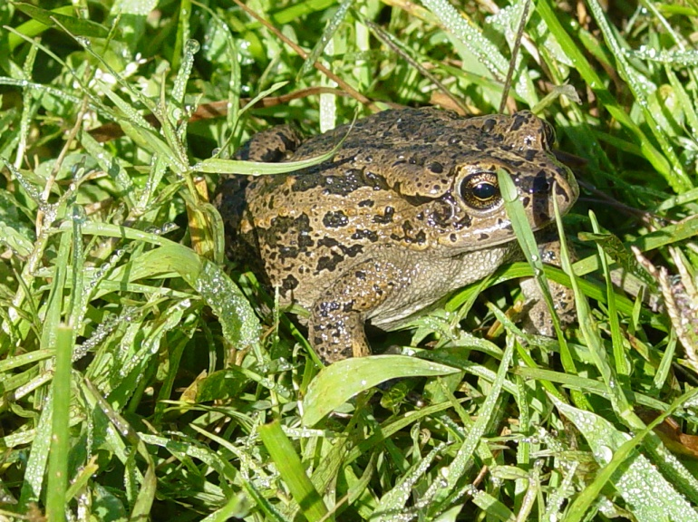
Diagnosis: Darkly pigmented subspecies of Green Toads of Asia; a light vertebral stripe may be present; no cranial crests; tympanum very small; parotids are slightly prominent and short.
Description of Holotype: Snout not protruding, rather snub, slightly shorter than horizontal diameter of the eye. Nostrils two times as distant from anterior margin of eye than from tip of snout. Interorbital space narrower than horizontal diameter of the eye. Tympanum very small. Parotids wide and short, only 1.2 times as long as wide. Dorsum with many, but only slightly prominent warts. Inner carpal tubercle about half as wide as the outer one. First finger longer than second, webbing short, at the three distal joints of the fourth toe only small dermal fringes. A weak tarsal fold. Subarticular tubercle single. Belly, especially in the middle nearly smooth. Tibia long, 2.53 times in the length of head and trunk. Tarso-metatarsal articulation does not completely reach to the tympanum. The dark dorsal spots fused, the original basic (i.e. the light) colour is mainly at the flanks and on the forelimbs. A light vertebral line present on the forehead. Ventral side dirty whitish with small grey spotting. SVL males 55-61 mm, females 68-72 mm.
Karyotype : 3n=33 ; Mating calls of males from Kulalai similar to those of tetraploid toads, B. pewzowi , B. oblongus and B. p. baturae from northern Pakistan, and different from those of diploid B. viridis; release calls have not been examined yet (Stöck et al. 1999).
Food: It feeds on insects and other arthropods. It is attracted under light posts to feed on insects and worms gathering under the light.
Habitat and Habits: This toad inhabits rocky areas. During the day, it hides under stones and retreats into fissures among rocks, swarming out at dusk.
Distribution: According to Stöck et al. (1999) the taxon appears to be distributed in open habitats within the zone of Himalayan dry coniferous forest with ilex oak and Himalayan moist temperate forest in the upper Swat valley. Eiselt & Schmidtler (1973) maintained the subspecific status and expanded the supposed range to Eastern Afghanistan and northern India. Dubois & Martens (1977) considered it conspecific to B. latastii. Both Baig (1998) as well as Stöck et al. (1999) independently proposed pseudoraddei to be a separate species.

Himalayan Rock Agama

Laudakia himalayana (Steindachner, 1867)

Fig. 2
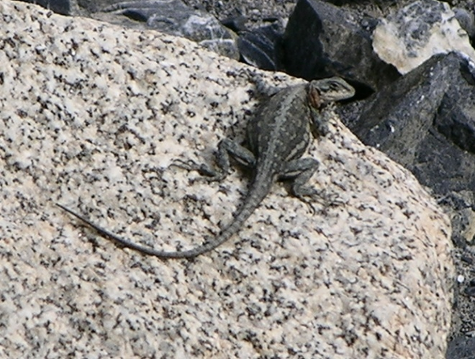
Description: Head and body much depressed; tympanum exposed , more than half of eye width; no gular pouch; upper head scales heterogenous; supralabials 10-14 (11±1), infralabials 9-12 (11±1); vertebral scales smooth or keeled, larger than other small dorsals, central 6 rows of smooth & roughly hexagonal, bordered by 3-4 rows of feebly keeled scales; no true patch of enlarged mucronate scales on flanks; other small dorsals distinctly smaller than enlarged vertebral ; ventral scales smooth; skin of lateral sides loose forming dorsolateral fold; total number of scales around midbody 122-166 (132 ±8.35); limbs less strong; fingers and toes compressed,l6-23 (19.7±1.73) lamellae under III finger and 24-32 (27.3±1.93) under IV toe, fourth. Tail much depressed, oval in cross section ; each tail segment consists of 3 complete whorls of moderatly enlarged , spinose scales; 26-43 (35±5.0) scales in first complete whorl around the tail; Callous glands present in males only at precloacal position, number of rows at precloacal position never exceed 3.
The species shows sexual dimorphism in color pattern which is more sharply demarkated in females as compare to males. Females have silver grey or olive ground color as compare to dull brown or yellowish brown in males. Head shows dark spots over light ground; gular reticulated ; chest and belly pale yellow in females and juveniles but in males with blue or grey wash; vertebral strip grey, irregular black spots forms festooned band on each side of vertebral line; olive grey above with dark rimmed yellow ocelli along the entire vertebral length in females, in males these ocelli are mainly concentrated on neck region; tail with dark spots which sometimes gives the impression of cross bars, the banded pattern is usually seen in females or juveniles. Besides these minor dissimilarities in color pattern of both sexes, females are clearly distinguishable from males for having red or bright orange collar region, juveniles have female pattern.

Distribution: Southern Pamir; Wakhan Corridor (Afghanistan); mountain ranges of Karakoram, Ladakh and Himalaya upto Tibbet above 2000m elevation.

Himalayan Pit Viper
Gloydius himalayanus (Günther, 1864)

Fig. 3
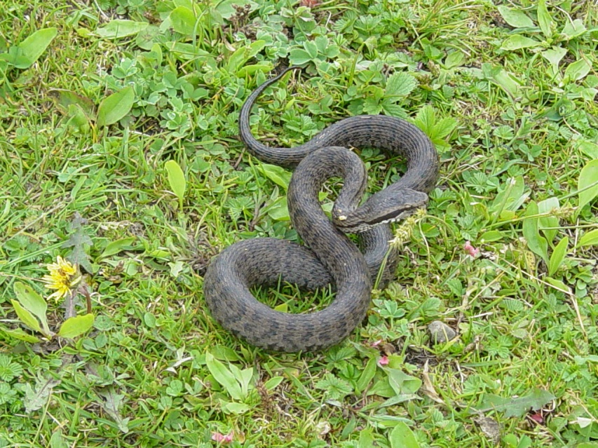
Description: Head of moderate size, distinctly wider than neck, snout blunt, very slightly turned up at the end, but only in large adults; rostral slightly higher than wide; two preoculars; pit on the sides of head; dorsal scales keeled, in 21: 21: 17 rows ; ventrals 147-175; subcaudals 42-53 in males and 36-48 in females; anal entire; subcaudals divided with few exceptions. Total length may exceeds 800mm, neonates 135-160mm; tail 96mm in males and 80mm in females.
The pattern of the body usually consists of a series of 25-45 dark cross bands, only slightly distinguishable from the ground color. It also exhibits black band from eye to beyond the angle of mouth and continues on the sides of the neck; upper labials pale, with dark stippling; belly dark with variable lighter mottling.
Habits & Habitat: This is a mountain snake occurs most commonly between 1500-5300 m elevations. It lives in rocky wooded mountain sides, in shady places with more or less closed canopies. Wall (1911) found it timid, sluggish and lethargic. Adults eat mainly mice whereas neonates eat small skinks. The species is viviparous and gives birth to 5-7 living young, borne during late August and early September (Telford, 1980). Wall (1928) reported that the bite of this viper is accompanied by local pain and swelling, but serious envenomation does not occur. Fenton (1910) wrote that he made several inquires but never heard of a fatal result from a bite. Gans (1978) provides some data on its venom.
Distribution: Southern face of the Himalayas in northern Pakistan, Kashmir (disputed territory), northern India and Nepal. The western limit may extend into Afghanistan and eastern into Sikkim.

Himalayan Ground Skink
Asymblepharus himalayanus (Günther, 1864)
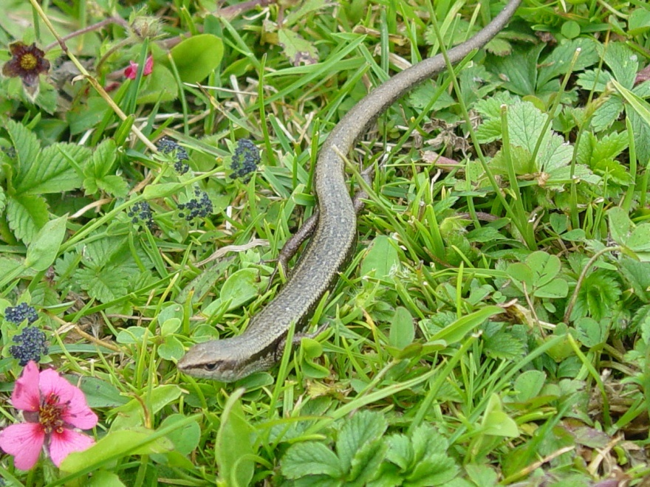
Fig. 4
Diagnosis: Differs from Scincella himalayanum for having a longer snout; a more slender body; 32—38 scales around mid-body; hind leg reaches to the wrist or elbow; 20-24 lamellae under toe 4. Color more or less similar to that of himalayana. SVL 50-55 mm.
Habits: Usually viviparous (some populations, such as at Gulmarg, may be ovivarous, Grüber 1981, as are those in Kumaon, India, Annandale 1907). 1-4 (usually 2-3) young in July and August. Food.-- Small beetles and orthoptera (Zugmayer,1909).
Distribution.-- Kashmir, India, Himalayan mountains and Deosai Plateau of Pakistan at 3200 — 6,000 m, the highest altitude attained for any lizard, in the areas of scattered bushes, grass and rock rubble (Grüber 1981)

4. Recommendations

- The selected sites were studied for shorter time spans, a more intensive and seasonal based study might surely result in identifying greater diversity of species.
- People are already in conflict with snake species due to their assumption of human health hazard and they want to eliminate snakes from the area. Proper awareness programmes are required and strict implementation of wildlife/environmental laws be given carried out.
- Awareness programs for conservation of those amphibians and reptiles which have slithering population due to anthropogenic and biotic factors should be conducted for the local people and school students so that they themselves feel the importance of wildlife and their role in ecosystem. Awareness should also be created about the negative impact on wildlife of the area by over-grazing, forest cutting and illegal hunting.
- Environmental Management Plan (EMP) for the locally threatened amphibians and reptiles is mandatory after repeated surveys to ascertain their population dynamics.
- Awareness should be created among the people to stop the heavy use of pesticides. Measures, which minimize the adverse affects of pesticides on living organisms, should be developed.

References

Annandale, N. 1906. Notes on the fauna of a desert tract in southern India. Part-I. Batrachians and reptiles, with remarks on the reptiles of the desert region of the North-West Frontier. Mem. Asiat. Soc. Bengal 1:183-202.
Annandale, N. 1907. The distribution of Bufo andersoni. Rec. Indian Mus., 1:171-172.
Annandale, N. 1912. Zoological results of the Ador Expedition 1911-1912. I. Batrachia. Rec. Indian Mus. 8:7-36.
Auffenberg, W. and Rehman, H., 1993. Studies on Pakistan Reptiles. Pt.3 Calotes versicolor. Asiatic Herpetological Res., 5: 14-30.
Baig, K.J. 1988 a. Anurans (Amphibia) of northern Pakistan: with special reference to their distribution. Pak. J. Sci.Ind. Res., 31 (9) : 651-655.
Baig, K.J. 1988 b. An unusual tail regeneration in Agama. Pak. J. Sci. Ind. Res., 31 (10) : 731-732.
Baig, K.J. 1988 c. New record of Agama nuristanica (Sauria: Agamidae) from Pakistan. Biologia, 34 (1) : 199-200.
Baig, K.J. 1989. A new species of Agama (Sauria: Agamidae) from northern Pakistan. Bull. Kitakyushu Mus. Nat.Hist.(Japan), 9 : 117-122.
Baig, K.J. 1990. Japalura kumaonensis: A new record of the.genus and species from Pakistan. Herpetological Review (USA), 21 (1) : 22.
Baig, K.J. 1992. Systematic studies of the Stellio- group of Agama (Sauria: Agamidae). Ph.D. Diss., Q.A.Uni., Islamabad.
Baig, K.J. 1996. Herpetofauna of the sub-Himalayan region of Pakistan including Islamabad area. Proc. DAAD 4th Follow-up Seminar, Islamabad :35-42.
Baig, K.J. 1997. Distribution of Laudakia ( Sauria: Agamidae) and its origin. pp 373-381. In: Mufti, S.A., Woods, C.A. & S.A. Hassan (eds), Biodiversity Of Pakistan.
Baig, K.J. 1998. The amphibian fauna of Azad Jammu and Kashmir with new record of Paa liebigii. Proc. Pakistan Academy of Sciences. 35 (2): 117-121.
Baig, K.J. 2001. Annotated Checklist of amphibians and reptiles of the northern mountain region and Potwar Plateau of Pakistan. Proc. Pakistan Acad. Sci. 38(2):121-130.
Baig, K.J. 2002. Rediscovery of Murree Hill Frog, Paa vicina after 130 years from Ayubia National Park. Proc.Pakistan Acad. Sci. 39(2): 261-262.
Baig, K.J. & Gvozdik, L., 1998. Uperodon systoma: Record of a new microhylid frog from Pakistan. Pak. J. Zool., 30 (2): 155-156.
Baig, K.J. & Böhme, W. 1991. Callous scalation in female agamid lizards (Stellio-group of Agama) and its functional implications. Bonn. Zool. Beitr. (Germany)
Baig, K.J. & Böhme, W. 1996. Description of two new subspecies of Laudakia pakistanica (Sauria: Agamidae). Russian J.Herpetology, 3 (1): 1-10.
Baig, K.J. and Rafique, M. 2005. Two new records of snake species from Machiara National Park, Azad Jammu and Kashmir. Proc. Pak. Acad. Sci., 42(2): 151-152.
Dubois, A. 1974: Liste commentee d’amphibiens recoltes au Nepal. – Bull. Mus. Natn. Hist. Nat. (3) 213; Zool. 143: 431-411.
Dubois A., Martens J., 1977 – Sur les crapauds du groupe de Bufo viridis (Amphibiens, Anoures) de I’Himalaya occidental (Cachmire et Ladakh). Bull. Soc. Zool. France, 102: 459-465.
Dubois, A. and Khan, M.S. 1979. A new species of frog (genus Rana subgenus Paa) from northern Pakistan (Amphibia: Anura). Jour.Herpetol., 13: 403-410.
Eiselt, J. & J. F. Schmidtler 1973. Froschlurche aus dem Iran unter Berucksichtigung ausseriranischer Populationsgruppen. – Ann. Naturhist. Mus. Wien 77: 181-243.
Fenton, L. L. 1910. The Snakes of Kashmir. J. Bombay Nat. Hist. Soc. 19:1002-4.
Gans, C. 1978. Reptilian venoms: some evolutionary considerations. Pp. 1-42. In C. Gans (ed.) Biology of the Reptilia. Vol. 8. Academic Press: London.
Grüber, U. 1981.Notes on the Herpetofauna of Kashmir and Ladakh. –Brit. J. Herp. 6: 145-150
Khan, M.S. 1989. Rediscovery and redescription of the highland ground gecko Tenuidactylus montiumsalsorum (Annandale, 1913). Herpetologica 45: 46-54.
Khan, M.S. 1993. A checklist and key to the gekkonid lizards of Pakistan. Hamadryad 18: 35-41.
Khan, M.S. 1997. A new toad of genus Bufo from the foot of Siachin Glacier, Baltistan, northeastern Pakistan. Pak. J. Zool., 29 (1): 43-48.
Khan, M.S. 1998. Typhlops ductuliformrs a new species of blind snakes from Pakistan and a note on Typhlops porrectes Stoliczka, 1871 ( Squamata: Serpentes: Scolicophidia). Pak.J. zool., 31 (4): 385-390.
Khan, M.S. & K.J. Baig 1992. A new tenuidactylid gecko fron northeastern Gilgit Agency, north Pakistan. Pak.J. Zool. 24: 273-277.
Khan, M.S. & Tasnim, R., 1989. A new frog of the genus Rana, subgenus Paa, from southwestern Azad Kashmir. J.Herpetology., 23 (4): 419-423.
Khan, M.S. & Tasnim, R., 1990. A new gecko of the genus Tenuidactylus from northwestern Punjab, Pakistan and southwestern Azad Kashmir. Herpetologica 46: 142-148.
Minton,S.A. 1966. A contribution to the herpotology of W.Pakistan. Bull.Am.Mus. Nat.Hist., 134(2): 28-184.
Sarker, A.K. 1984. Taxonomic and ecological studies on the amphibians of Calcutta and its environs. Rec.Zool.Survey.India. 81 (3-4): 215-236.
Stöck, M., Schmid, M., Steinlein, C. and Grosse, W. 1999. Mosaicism in somatic triploid specimens of the bufo viridis complex in the Karakorum with examination of calls, morphology and taxonomic conclusions. Ita.J.Zool., 66: 215-232.
Stöck, M., Günther, R. and Böhme, W. 2001a. Progress towards a taxonomic revision of Asian Bufo viridis group: Current status of nominal taxa and unresolved problems (Amphibia: Anura: Bufonidae). Zool. Abh.51(18): 253-319.
Stöck, M.,Frynta, D., Grosse, W., Steinlein, C. and Schmid, M. 2001b. A review of the distribution of diploid, triploid and tetraploid Green Toads (Bufo viridis complex) in Asia including new data from Iran and Pakistan. Asiatic Herp. Res., 9: 77-100.
Stoliczka, F. 1872. Notes on some new species of Reptilia and Amphibia collected by Dr. W. Waagen in northwestern Punjab. Proc. Asiatic Soc. Bengal, pp. 124-132.
Telford, S. R., III. 1980. Notes on Agkistrodon himalayanus from Paksitan’s Kaghan Valley. Copeia 1980:154-155.
Wall, F. 1911. Reptiles collected in Chitral. J. Bombay Nat. Hist. Soc. 21:132-145.
Wall, F. 1928. The Poisonous snake of our British Indian Dominions (including Ceylon) and how to recognize them. With symptoms of snake poisoning and treatment. 4th edition, Bombay, 149 pp.
Whitaker, R and Captain, A., 2004. Snakes of India, The Field Guide. Draco Books, India. 479 pp.
Zugmayer, E. 1909: Beitrage zur Herpetologie von Zentral-Asien. – Zool. Jahrb., Abt. Syst., Okol., Geograph. Tiere 27:481-508.

__________________________________

Annexure-I: Sampling sites/Line transects selected for the baseline studies of Kaghan Temperate Coniferous Forest

S. No. | Sampling Transect | Start point (SP) | End Point (EP) | Habitat Type
1 | T-1 | 34 42 21.5 N  73 26 14.7 E | 34 42 21.5 N  73 26 14.7 E | Himalayan Moist Temperate Forest
2 | T-2 | 34 42 11.9 N  73 26 27.2 E | 34 42 08.7 N  73 26 45.8 E | Himalayan Moist Temperate Forest
3 | T-3 | 34 41 54.9 N  73 26 58.4 E | 34 41 38.7 N  73 27 05.9 E | Himalayan Moist Temperate Forest
4 | T-4 | 34 41 26.3 N  73 27 00.2 E | 34 41 24.1 N  73 27 38.3 E | Himalayan Moist Temperate Forest
5 | T-5 | 34 41 17.1 N  73 26 02.9 E | 34 41 31.0 N  73 25 51.1 E | Himalayan Moist Temperate Forest
6 | T-6 | 34 42 06.1 N  73 25 49.8 E | 34 42 24.1 N  73 25 44.3 E | Himalayan Moist Temperate Forest

